|  |  |  |  |
| --- | --- | --- | --- |
|  | March 2018 |  | |
|  | |  | |
| ***Company Profile*** | | |
|  |  |  | |
|  |  | PR Department. | |

Green Libya Oil Services Inc.

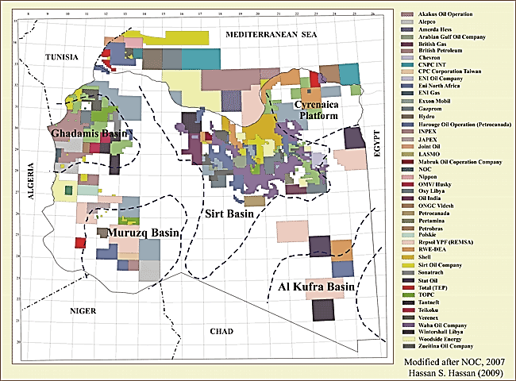



Massage from the Board

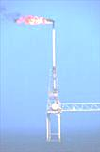

Dear Reader;

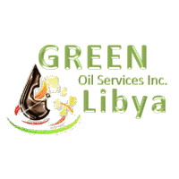

Substantiated technology transfer hub.



GREEN LIBYA Oil Services Inc.

GREEN LIBYA Inc., acts as a conglomerate of companies and organizations dedicated to perfection and absolute customer satisfaction; namely

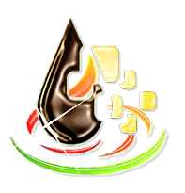

* The Conservatives Association for Environment Protection (CAEP).
* TERRA Management Ltd., in projects engineering services.
* DPS Process System Integrators & Seismic Analysis Ltd.
* Apollo Separation Technology Ltd.

During our first year of business 2010, we succeeded in generating cooperative links with high potential public-sector clients: The National Demining Program & the Civil Defense Authority

The core business of the group-network is providing excellent services and supplies to Oil & Gas Industry companies operating within the territory of North Africa as well as the Libyan authorities. By exceeding all requirements and by providing the highest quality product at the shortest possible delivery time.

Our group engineering and contracting affiliates are loaded with dynamic experience, along a rich know-how to resolve your specific issues and problems; by implementing the most advanced combination of high-tech, state-of-the-art and up to date commercial solutions.

We value our relationships with current and future customers and hope to communicate our appreciation to them through our outstanding, guaranteed product quality, personal service, and efficient delivery. Our commitment to our customers and to Libya will be reflected through honest and responsible business.

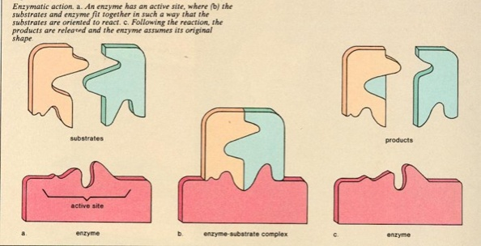

As new Libya is born in 2011, we will focus on the environment issues as a contribution from us to the Libyan society.

Our Philosophy

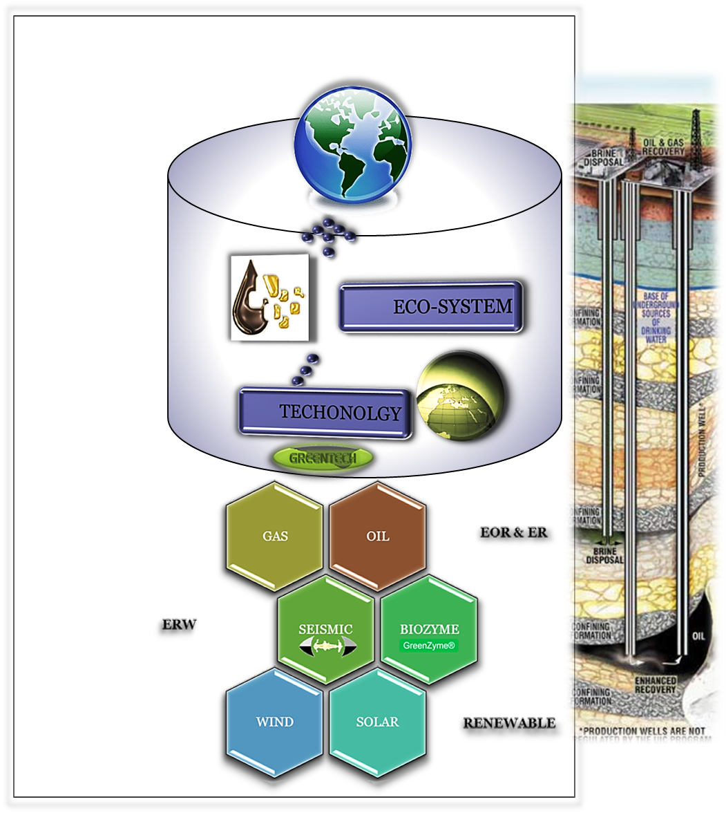

To have an impact;

We shall share all our environmental concerns with the community, to ensure the cleanest E&P.

Access to International Markets & Resources

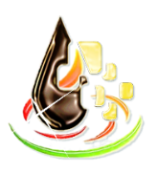

Act as a think-tank

Fit local demands

Enhance eco-system solutions





Scope of Services and Products

Offering affordable, top of the line electrical and mechanical products, of a very wide range. We are also specialized in working only with top quality products and suppliers in the mechanical and electrical industries today.

* Products: Bio Enzymes.

Advanced Seismic SAG-Y Data Processing Software

* Services: EOR (Well treatments)

NORM, ER, UXO (Clean ups)

* Consultancy Risk Management

Our Vision:

Our plan is to employ and coach qualified graduate scientists and engineers, they will join the promising career opportunities in the oil fields services sector.

Building skilled staff to be available with regard to technical principles is believed to be the wisest investment the company can do for the next coming years.

Safety Policy Statement

Holding safety is one of our most important responsibilities in the operation of this organization. Totally, we believe that production and safety go hand in hand and that a safe working environment leads to improved production. At this time, a renewed effort must be placed on safety by every employee at this facility.

Company Safety Rules

The company considers providing a safe and healthy working environment as a main target. To do this, we must constantly be aware of conditions in each individual’s work area that can produce injuries. No employee is required to work at a job that is not safe or healthful. Employee cooperation in detecting hazards, and in turn controlling them, is a condition of employment. The GENERAL SAFETY RULES and procedures govern all employees and all company operations. These rules are not meant to be all-inclusive since in many departments more specific rules are necessary for a smooth and safe operation. Additions to, and deletions from, or modification of these rules will be made anytime it is determined necessary for the safety and wellbeing of all personnel.